Going Beyond

Descriptive Analytics: Data Visualization and Storytelling with Data

# Ethics, Deception, and Fallacies

**"There are three kinds of lies: lies, damned lies, and statistics."** - Mark Twain

Any time we create a visualization, we create an abstract model of the data. Visualizations present information from the viewpoint and understanding of the designer. Any encoding of the data makes some assumptions about the audience and how they will interpret it. The designer has the responsibility to ensure that the data is represented as truthfully and objectively as possible because they have the ability to mislead, deceive, or confuse.

Have you ever seen a chart that you were not sure how to interpret? Or have you ever seen a chart where you thought you knew how the data was encoded, but upon reading the axes labels or annotations, were left confused? Some data visualizations are simply poorly designed but others are intentionally misleading.

As we saw earlier in the course, visualizations can be used as part of the reasoning process. However, they can also be used to rationalize situations where the audience may experience cognitive dissonance and/or confirmation bias because of the way they interpret the facts being communicated. Knowing how to avoid misrepresenting data and recognizing when this may be occurring are critical skills.

Deceptive or hard to read charts stem from violations of the principles we have covered in this course. The most obvious errors are abuses of the grammar of graphics such as:

* **Dual y-axis:** Manipulating either of the y-axes enables one to create spurious relationships. This is because having inconsistent scales mapped to the same coordinate system tricks the eye into perceiving relationships on an implicit common scale (Figure 1).

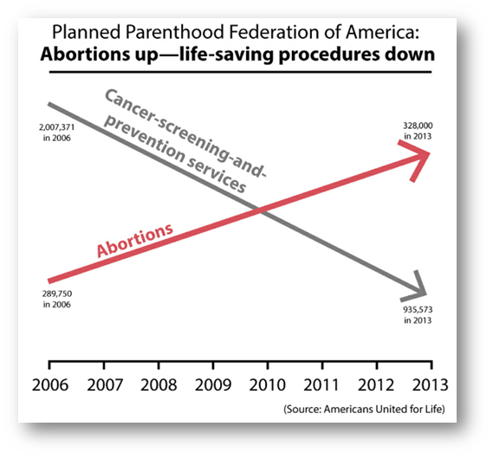

*Figure 1: Two graphs plotted on the same plane but with different y-axis scales (Source:* [*How Charts Lie*](http://www.thefunctionalart.com/2020/01/all-graphics-from-how-charts-lie-freely.html)*)*

Without any y-axis scales, the chart purposely hides the widely different scales of the two axes. One scale has been greatly exaggerated making it appear that there is almost a proportionately inverse relationship between the two services.

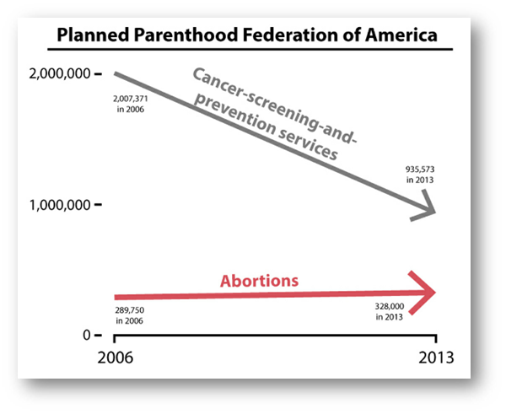

*Figure 2: The same two graphs as in Figure 1 plotted on the same y-axis scale (Source:* [*How Charts Lie*](http://www.thefunctionalart.com/2020/01/all-graphics-from-how-charts-lie-freely.html)*)*

Plotting the series on a common axis shows the true comparison between trends.

* **Non-zero baseline:** Not starting graphs like bar charts from a zero baseline can amplify differences (Figure 3 and 4). Without a reference point, the range of scales can be manipulated so that small differences can appear large (and the reverse can be done as well to make large differences appear small).

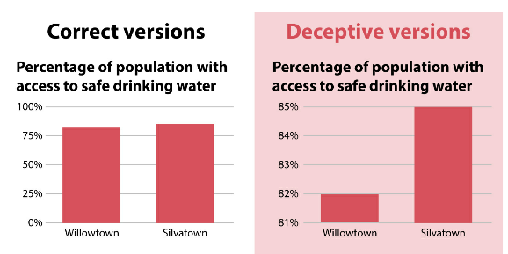

*Figure 3: The bar chart on the left starts from zero while the one on the right starts from a higher point, 81%, amplifying the perceived differences in the heights of the graphs (Source:* [*How Charts Lie*](http://www.thefunctionalart.com/2020/01/all-graphics-from-how-charts-lie-freely.html)*)*

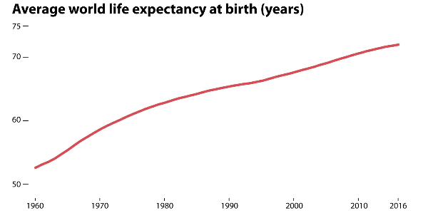

*Figure 4: A chart showing the world average life expectancy in years between 1960 and 2016 with years on the x-axis and the age beginning with 50 on the y-axis (Source:* [*How Charts Lie*](http://www.thefunctionalart.com/2020/01/all-graphics-from-how-charts-lie-freely.html)*)*

* **Stretched proportions:** Stretching proportions, using inconsistent scales, or using irregular scales can lead to widely different interpretations (Figure 5 and 6).

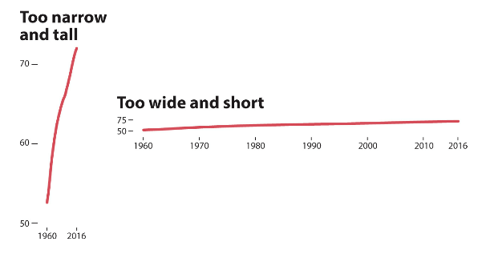

*Figure 5: The same data as shown in Figure 4 only with the x-axis too narrow (left side) and the y-axis too short (right side) (Source:* [*How Charts Lie*](http://www.thefunctionalart.com/2020/01/all-graphics-from-how-charts-lie-freely.html)*)*

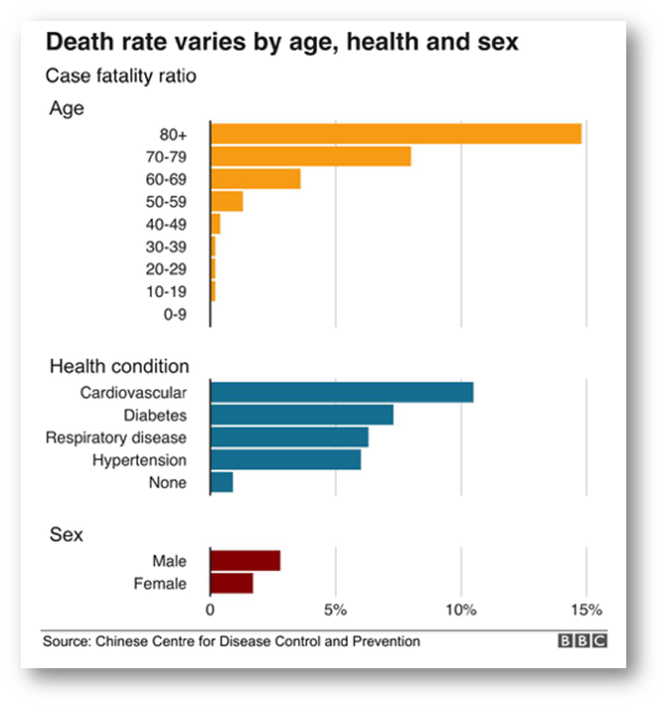

*Figure 6: Bar chart showing death rates based on age, health condition, and sex WITHOUT labels on the individual bars (Source: Chinese Centre for Disease Control and Prevention)*

Can you spot any issues with the above visualization? Compare it to these redesigns (Figures 6 and 7):

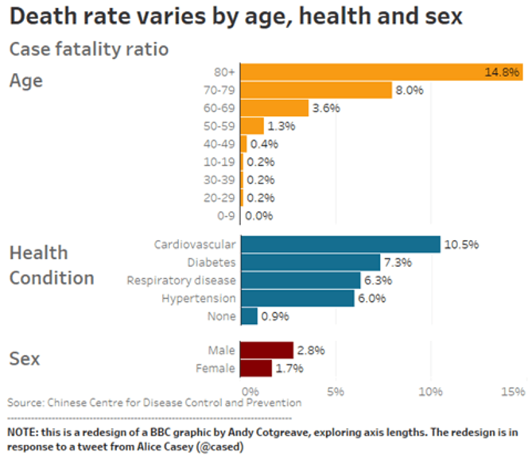

*Figure 7: Bar chart showing death rates based on age, health condition, and sex WITH labels on the individual bars (Source: Chinese Centre for Disease Control and Prevention. Note: This is a redesign of a BBC graphic by Andy Cotgreave, exploring axis lengths. The redesign is in response to a tweet from Alice Casey (@cased). )*

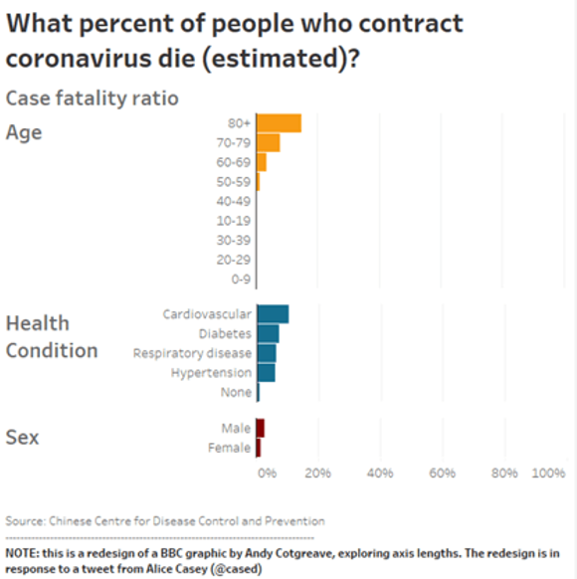

*Figure 8: Bar chart showing death rates based on age, health condition, and sex plotted on a scale of zero to 100%. (Source: Chinese Centre for Disease Control and Prevention. Note: This is a redesign of a BBC graphic by Andy Cotgreave, exploring axis lengths. The redesign is in response to a tweet from Alice Casey (@cased). )*

Other potentially problematic concerns stem from underlying data issues and are much harder to detect.

* **Cherry picking**: Selecting results that fit your claim and excluding those that don’t
* **Survivorship bias**: Drawing conclusions from an incomplete set of data because that data has survived some selection criteria
* **False causality**: Assuming that when two events appear together or appear to be related, one must have caused the other
* **Gerrymandering**: Manipulating boundaries used to group data in order to change results
* **Sampling bias**: Drawing conclusions from a set of data that isn’t representative of the population you’re trying to understand
* **Gambler’s fallacy**: Believing that because something has happened more frequently than usual, it’s now less likely to happen in the future (or vice versa)
* **Simpson’s Paradox:** When a trend appears in subsets of data but disappears or reverses when the groups are combined
* **Mcnamara Fallacy**: Relying solely on metrics in complex situations and losing sight of the bigger picture.

Data issues underlie the majority of unintentionally misleading charts. Knowing how to vet, prepare, and clean data is one of the hardest challenges facing any analyst. As the saying goes, “garbage in = garbage out.” Applying good visualization methods to bad data only leads to bad visualizations. Because it is fairly easy to manipulate perceptions through intentional design, it’s the designer’s responsibility to:

* Ensure clean, objective data
* Create truthful representations of the data in their visualizations
* Call out those who do not adhere to the above two principles

Finally, there is an ever-present danger that someone might read more into a chart than is actually present or attribute more significance to particular artifacts than is warranted even if the graphic is presented as truthfully and honestly as possible. (See Figure 9 for an extreme example of this.)

*Figure 9: S&P 500 financial data with a whimsical (and completely meaningless) interpretation overlaid (Source:* [*Steemit*](https://steemit.com/psychology/@kyriacos/why-technical-analysis-in-trading-is-100-bullshit)*)*

Visualizations are meant to create mental scaffolding for the data, environment, and relationships. However, they should never be used in place of proper scientific, statistical, or modeling methods.

# Deploying and Publishing

In the past, deploying and publishing visual analytics was challenging for many organizations. The underlying data management and engineering pipelines were much less capable than today’s backend systems. As new analytical platforms enter the market and mature over time, the deployment and publication of analyses and visualizations will become increasingly trivial as long as the supporting data pipelines are robust.

The deployment and publication of descriptive analytics span the gamut from one-off projects to auto-generated, periodic, or even real-time feeds:

Descriptive analytics appear in a variety of formats ranging from one-off projects to automatically generated, periodic or real-time feeds. Here are several examples:

* Articles
* Reports
* Presentations
* Dashboards
* Real-time monitoring systems
* Immersive systems

Modern data analysis software often provides the following capabilities:

* WYSIWYG editing of graphs
* Data imports and exports
* API connectivity
* Database connectivity
* Interactive data manipulation and exploration
* Drag-and-drop interface and graph creation
* Customizable graphing
* Custom theming
* Brushing and linking
* Univariate and multivariate analytics
* Deployment options
* Dashboarding
* Report generation
* Automation

The number of vendor tools in the visualization market is growing at breakneck speed and the capabilities of these tools are similarly expanding. In most cases, deploying analytical results to local servers or cloud-hosted systems is no harder than making a few clicks on a simple user interface. Nevertheless, it is rare to find a single tool that can address all the needs of a project. Consequently, spreadsheet applications like Microsoft Excel are often used to “fill in” the missing capabilities, a practice that is more prevalent in companies that have relatively immature analytical capabilities. Thus, it is a good idea to avoid being wedded to any particular platform, language, or tool, and to focus instead on knowing how to apply core analytics and communications principles to any platform. Being creative and flexible in the use of software tools is the mark of a standout data visualization expert.

# Custom Visualizations

The challenge of using off-the-shelf tools is that despite the functionality being well-covered for 90% of use cases, it requires significant work for the remaining 10%. When novel visualizations or patterns of interaction are required, creating visualizations using existing toolsets can become a daunting challenge. In niche instances where none of the existing toolsets provide a satisfactory way to create a bespoke visualization or interaction, it is worth first considering:

* **The objective of the visualization**: Does a custom visualization really provide more information that cannot be expressed in any other way?
* **The audience**: Would the audience be able to quickly understand a non-standard plot without much explanation?
* **Data manipulation**: Can the data be simplified so it can be visualized with standard graphics?

If a custom visualization is still warranted, the graphic must be developed from the ground up. Even in these cases, the principles of the grammar of graphics still hold. These include:

* **Data**: the information/statistics to be visualized
* **Geometry**: the representation of data as a spatial feature
* **Aesthetic**: the mapping of data features to attributes such as color, size, etc.
* **Scale**: the mapping of data to spatial, aesthetic, geometric scales
* **Coordinates**: the scale system used for positioning attributes

## JavaScript and D3.js

Generally, most bespoke visualizations must be interactive, deployable at scale, and able to process large amounts of real-time data. Consequently, the language choice for developing custom visualizations is increasingly becoming *JavaScript*, informally known as “the language of the web.”

JavaScript has reigned as the most popular programming language since [*RedMonk*](https://redmonk.com/sogrady/)began compiling its programming language rankings back in 2010. JavaScript is easy to learn, popular as a client-side language for all web browsers, increasingly popular for server-side programming (via node.js), and generally useful as a one-size-fits-all language.

The most popular JavaScript library for interactive web visualizations is *D3.js*. Created as an evolution of the Protovis visualization toolkit (developed by the Stanford Visualization Group), D3.js is now considered by many to be among the best visualization libraries.

D3.js allows developers to:

* Manipulate web documents
* Create SVG objects
* Animate transitions
* Add interactivity
* Add dynamic effects
* Style elements using CSS

The power of D3.js lies in its ability to map data to any element and attribute in the DOM, CSS, or SVG with its associated attributes (color, shape, size, etc.), behaviors, and D3.js-specific structures. This means that any visualization created with D3.js is immediately deployable and performant since it only uses lightweight client-side resources for page creation. It is also extremely flexible for any type of visualization and interactive design.

In conjunction with data-manipulation JavaScript libraries like [Arquero](https://www.npmjs.com/package/arquero), D3.js can create data-driven interactive and animated graphics with real-time capabilities. There are several libraries built on top of D3.js that provide higher-level wrappers for various chart components and pre-canned visualization libraries. (For a list of these libraries, visit the [Awesome D3 page](https://github.com/wbkd/awesome-d3) on GitHub.)

The downside of D3.js is that the learning curve can be very steep since users must know:

* JavaScript
* DOM manipulation
* SVG manipulation
* CSS
* D3.js functions
* Data manipulation libraries
* APIs
* Web programming

Fortunately, specialized computing notebooks made for JavaScript and D3.js (such as those offered by the company [Observable](https://observablehq.com/)) can aid in learning. In addition, a great resource for seeing what is possible can be found by browsing a [gallery of example visualizations on the Observable website](https://observablehq.com/@d3/gallery) and viewing the source code for the visualizations directly.

Using D3.js can be a daunting challenge because of its rather low-level mapping of data to graphical objects. On the other hand, there simply is no better framework for custom visualizations at present for any web-deployed environment.

## Using Designer Tools

### Adobe Illustrator

*Adobe Illustrator* is a popular digital design tool for manipulating graphics that data scientists can use to enhance visualizations. Adobe Illustrator includes built-in features for importing and charting data, and while these capabilities are rather limited and are in no way a replacement for more dedicated tools, Illustrator is useful for editing PDF files, SVG files, and images easily. More importantly, any attribute of any object in Illustrator, including vector graphics, images, text, shapes, etc., can be mapped to data. From the grammar of graphics, we understand that any data visualization is a layering of scaled mappings of data to geometries and aesthetics (attribute and position) using a coordinate system. Each of these components has an analog in Illustrator. Consequently, sophisticated data visualizations can be crafted like digital designs.

The *infographic* was once “all the rage" in the data visualization world. The term ‘infographic’ (a conjoining of *information* and *graphic*) differentiates itself from standard visualizations by a lack of assumptions about its viewers. Infographics are known for being highly designed, colorful, illustration-heavy, and explanatory. Their use has proliferated in the media for the way they draw attention and garner clicks. In analytics, the use of infographics has declined in recent years as data scientists tend to favor standard visualizations. In many cases, however, Illustrator can be used to great effect to create eye-catching, information-rich visualizations which do not detract from their main purpose. Some great examples of effective use of Illustrator to create infographics can be found at [VisualCapitalist](https://www.visualcapitalist.com/) and [FlowingData](https://flowingdata.com/).

### Adobe After Effects

For those familiar with the Illustrator interface, *Adobe After Effects* provides an additional level of control over the visualization. Specifically, After Effects provides the ability to animate data with fine-grained control over transitions, effects, and parameters. Each aspect of the animation can be controlled by a parameter that can be mapped to a data variable.

As an illustrative example, consider the mapping of visual elements to audio elements such as an audio spectrum analyzer. In this case, audio frequencies and their magnitudes are mapped to a visual display using Adobe After Effects. As music plays, the display changes in response to both the audio frequency and amplitude. The result is a responsive, animated, spectrum that “dances” to the pulse of the music (Figure 10).



*Figure 10: Spectrum bar visualization (Source:* [*swharden*](https://github.com/swharden/Python-GUI-examples/blob/master/LICENSE)*)*

A simple change of the graphics design, coordinates, aesthetics, and geometry create an entirely different visual appearance (Figure 11). The underlying data and how it maps the data to the visualization is the same, but the appearance is different. The possibilities for enhancing and enriching any visualization are suddenly greatly expanded.



*Figure 11: Circular visualization of music pulse*

The concept of mapping a data variable to an object in the graphic can be applied to any time-varying dataset. The visual attributes of the data variable thus reflect the value of the variable at each point in time (Figure 12)

The dedicated timeline control interface of After Effects makes fine-tuning and customizing animated data visualizations a much more design-oriented experience. In fact, most science fiction movies and TV shows showing futuristic interfaces or data visualizations use After Effects (or similar programs) to create a vision for the future of visualization. And yet, it is possible to create those futuristic, animated visualizations today (Figure 13).

 *Figure 12: Wave visualization depicting time-varying data*

### From Dino Ignacio, Minority Report. Creating futuristic visualizations and interfaces using common off-the-shelf tools like After Effects.

*Figure 13: From Dino Ignacio, Minority Report. Creating futuristic visualizations and interfaces using common off-the-shelf tools like After Effects*

## Game Engines: Unreal Engine and Unity3D

Some visualizations require interactivity or immersion. In these cases, none of the aforementioned software solutions are appropriate. For interactivity and responsiveness, no tool can quite match a game engine whose primary goal is to provide real-time responsiveness to interactive graphics. Game engines come in two flavors: two-dimensional (2D) engines and three-dimensional (3D) engines. Increasingly, 3D engines can support either 2D or 3D interactive environments equally well. Consequently, some of the most widely used game engines, such as [*Unreal Engine*](https://www.unrealengine.com/en-US/) and[*Unity3D*](https://unity.com/), serve as excellent platforms for performing both 2D and 3D interactive visualizations. Objects in a game are essentially collections of data points describing the shape, texture, color, position, velocity, acceleration, etc. at any point in time. This is nothing other than a mapping between data points to visual elements. (See Figure 14 for an example visualization using Unity3D to map geospatial data.)

Architects can use 2D blueprints with elevation data to create 3D models that can be imported into a game engine for interactive visualization. This allows their clients to have a more immersive experience as they view architectural project designs. Similarly, engineers can import computer-aided design (CAD) models and even run interactive simulations that take into account physics (e.g., the effect of gravity) and material properties. Finally, chemists and biologists can work with 3D representations of protein folding as they apply virtual manipulation to determine optimal configurations.

In each of these examples, the data is manifested in 3D space as virtual physical objects. Behind the physical representation is nothing more than a set of data points. Any 3D subspace of a feature set can be similarly mapped to regions in a 3D coordinate system. Additional features can be mapped to different geometries, aesthetics, etc. The coordinate system need not represent actual physical space. Rather, it can represent numerical positions corresponding to a ‘feature’ space rather than actual physical space. A [recorded presentation by Sean Whiteley](https://www.youtube.com/watch?v=myexK40c1r4) (given at the Unite Singapore 2019 Conference) provides a more in-depth introduction to the use of game engines for visual analytics.

A game engine provides an easy way to import, manipulate, and visualize data in 2D/3D Cartesian space. The primary advantages are that the engine features several built-in capabilities such as the ability to apply the laws of physics to objects (e.g., have objects move under the effects of gravity, as mentioned earlier), handle animations and timeline control, provide interface overlays that augment the graphical information, and foster a highly responsive, interactive experience.

The interaction inputs are also highly flexible and allow for customizable keystrokes, mouse interactions, mobile gesture support, sensors, haptic feedback control, and even future user interactions yet to be defined.

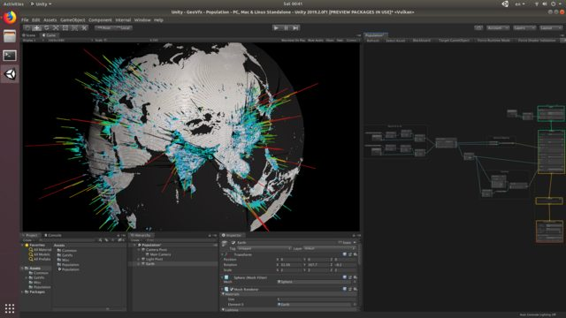

*Figure 14: An example using VFX Graph to map geospatial data in Unity3D (*[*https://github.com/keijiro/GeoVfx*](https://github.com/keijiro/GeoVfx)*)*

There are three visualization features found in game engines that have the potential to significantly change the way we view and interact with data:

* **Projection mapping** uses real-world objects as screens on which to display visuals, which are transformed so they appear to match real-world perspectives and scales. This technique has been used in a variety of fields to alter the appearance of large-scale structures, aid in engineering projects, and even provide non-invasive medical training. The computing requirements (hardware and software) are relatively low making this an accessible approach for displaying complex visualizations with real-world references.
* **Augmented reality** allows users to view virtual objects overlaid on top of the real world through special lenses or through a traditional screen. This technology is already being used in manufacturing, construction, and engineering. Real-time information augmentation allows for the referencing of real-world objects and interactivity from multiple perspectives.
* **Virtual reality**: Total immersion in a virtual environment presents unlimited possibilities for visualizing and interacting with data. The visualizations and interactions no longer need to be confined by real-world physical attributes but can be completely redefined by the developer.

# The Future of Visualization

The fundamental ways in which we visualize data have evolved surprisingly little since the early years of mapping cholera outbreaks. Standard bar charts, line charts, heat maps, geospatial maps, network diagrams, histograms, density plots, and scatter plots are timeless types of visualizations used for both univariate and multivariate analyses. Fundamentally, the grammar of graphics underlies the effectiveness of all these charts. Data can be mapped in logical ways to graphical attributes such as scale, color, position, and size. We no longer need to understand explicitly how to perform this mapping, but instead can rely on the appropriate standard chart to serve our purpose. Though the technology behind data visualization is rapidly changing, the principles and objectives remain the same.

What *is* changing is our understanding of how to analyze data visually and how to communicate our findings. As visualization tools and techniques combined with a better understanding of how to use them have improved over the years, we have been able to maximize the effectiveness of our visualizations by:

* Increasing the information content of the visualizations
* Guiding users through focused storylines involving the visualizations
* Applying effective design concepts to visual communication

This shift in understanding has been leading to technological improvements, as well, which have allowed us to become interactive, immersive players directly within the visualization—and there is no end in sight. The manner in which we gather data and later interact with it is likely to continue evolving in surprising ways into the foreseeable future.